

Rickey

D.

Callahan,

Broker

Callahan

Properties

**EX**

**C**

**L**

**U**

**S**

**I**

**V**

**E**

**LI**

**S**

**TI**

**N**

**G**

**!**

Property for Sale:

945

, 951, 953 S. Buckner Blvd., Dallas, TX

75217

**Recently Reduced!! ~~$695,000.00~~ to $649,500.00**

**8344**

**East R.L. Thornton Frwy., Suite 308**

**Dallas, Texas 75228**

**Office: 214.328.5775**

**info@callahancommercial.com**

Information contained herein was obtained from sources we believe to be reliable. We make no guarantee, warranty or representation

about it. It is subject to the possibility of errors, omissions, and change of price, rental or other conditions prior to sale, lease,

financing or withdrawal without notice.

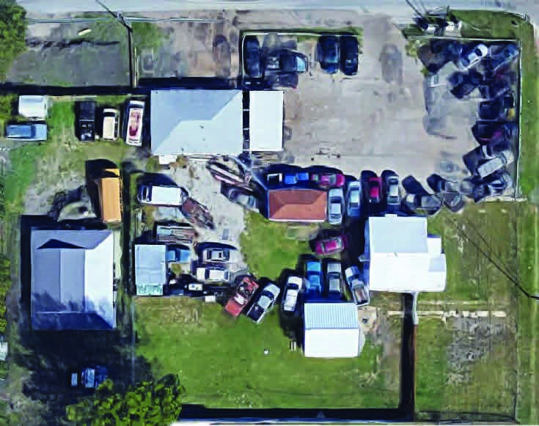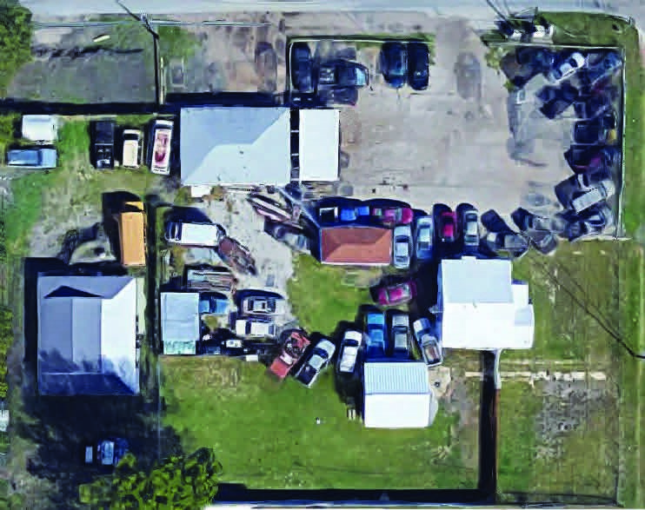

Rickey

D.

Callahan,

Broker

Callahan

Properties

**Size 40,920 Sqft +/-**

**8344**

**East R.L. Thornton Frwy., Suite 308**

**Dallas, Texas 75228**

**Office: 214.328.5775**

**info@callahancommercial.com**

Information contained herein was obtained from sources we believe to be reliable. We make no guarantee, warranty or representation

about it. It is subject to the possibility of errors, omissions, and change of price, rental or other conditions prior to sale, lease,

financing or withdrawal without notice.



Rickey

D.

Callahan,

Broker

Callahan

Properties

**Location**

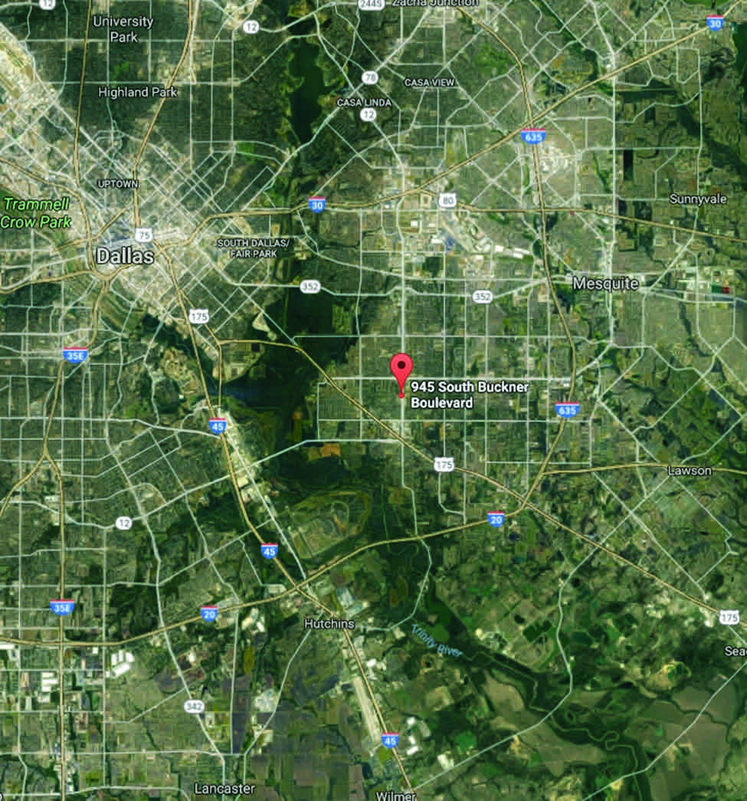

**Nearby Businesses**

Rickey

D.

Callahan,

Broker

Callahan

Properties

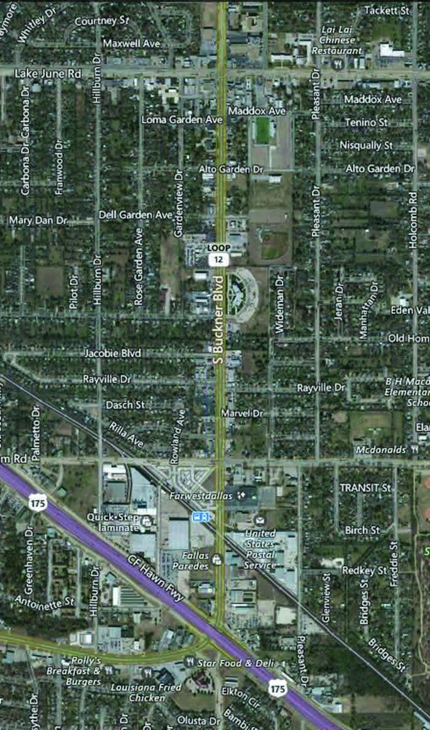

**Traffic Counts**

**East R.L. Thornton Frwy., Suite 308**

**8344**

**Dallas, Texas 75228**

**Office: 214.328.5775**

**info@callahancommercial.com**

Information contained herein was obtained from sources we believe to be reliable. We make no guarantee, warranty or representation

about it. It is subject to the possibility of errors, omissions, and change of price, rental or other conditions prior to sale, lease,

financing or withdrawal without notice.

Rickey

D.

Callahan,

Broker

Callahan

Properties

