NORTH & SOUTH VIA CEDAR CREST BLVD.
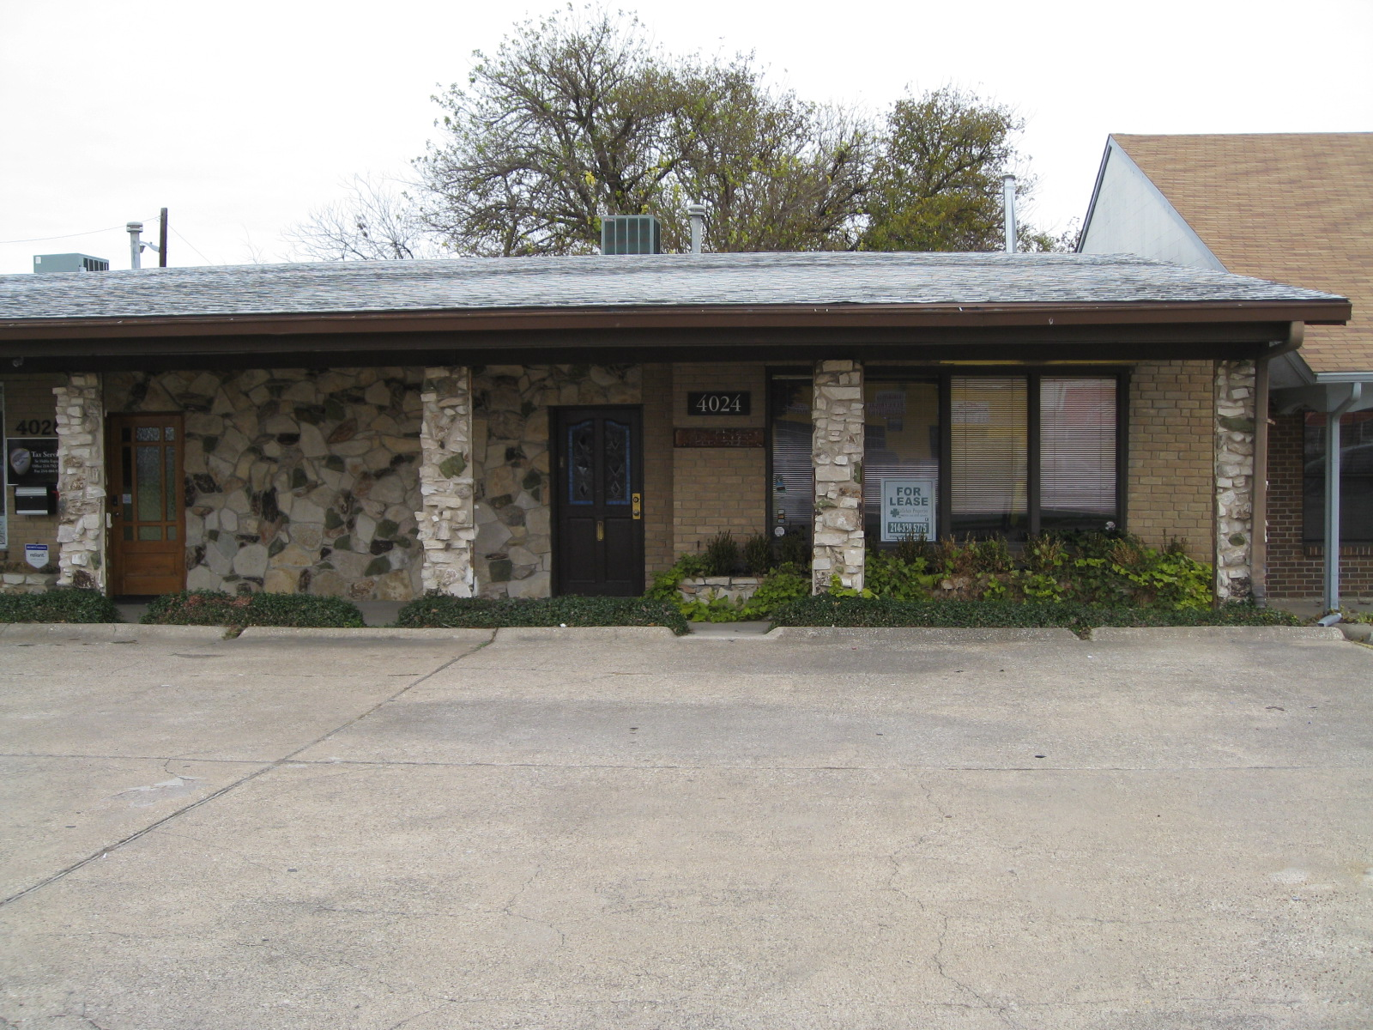
PROPERTY FOR LEASE
EXCLUSIVE LISTING!

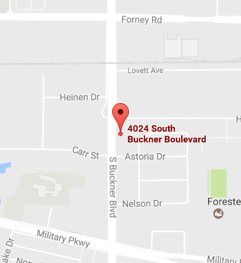
MISCELLANEOUS:
LAND:
ZONING:
UTILITIES:
ACCESS:
LOCATION:
BUILDINGS:
MAPSCO:

EAST & WEST VIA BONNIE VIEW ROAD

NORTH & SOUTH VIA CEDAR CREST BLVD.
4024 S.BUCKNER BLVD.SUITE A
DALLAS, TX 75227
EAST & WEST VIA BONNIE VIEW ROAD
NORTH & SOUTH VIA CEDAR CREST BLVD.
EAST & WEST VIA BONNIE VIEW ROAD
NORTH & SOUTH VIA CEDAR CREST BLVD.
EAST & WEST VIA BONNIE VIEW ROAD
NORTH & SOUTH: BUCKNER BLVD.
EAST & WEST: FORNEY RD. & MILITARY PKW
N/A
48-Q
1,800 SF OF LARGER SPACE

PLANNED DEVELOPMENT DISTRICT
CELL: (214) 354-1100
OFFICE: (214) 328-5775
FAX: (214) 328-6366
EMAIL: rcallahan1985@aol.com CELL: (214) 354-1100
OFFICE: (214) 328-5775
FAX: (214) 328-6366
CELL: (214) 354-1100
OFFICE: (214) 328-5775

FAX: (214) 328-6366
EMAIL: rcallahan1985@
ALL AVAILABLE TO SITE

RICKEY CALLAHAN

OFFICE: (214) 328-5775
FAX: (214) 328-6366
EMAIL: info@callahancommercial.com
8344 East R.L. Thornton Frwy, Suite 308
Dallas, Texas 75228

Based on a 3 Year Lease per Month
$1,700.00, $1,750.00, $1,850.00

RENTAL PRICE:

Perfect for CPA, Lawyer, Insurance

Information contained herein was obtained from sources we believe to be reliable. We make no guarantee, warranty or representation about it. It is subject to the possibility of errors, omissions, and change of price, rental or other conditions prior to sale, lease, financing or withdrawal without notice.

